The Regeneration of The People’s Market, Wrexham, offering a unique diverse range of opportunities and uses.

“The People’s Market Community Hub”

“Plan B”

Date: - 3rd January 2016

Prepared by: - The Wrexham Business Group (BG), Representatives of the Market Traders (MT), and Members of the Town Centre Forum (TCF)*

Report to: - Wrexham County Borough Council (WCBC), Employment, Business and Investment Scrutiny Committee (EBISC), and Executive Board.

Prepared by: - Nigel Lewis (Chartered Quantity Surveyor, Chair Wrexham Town Centre Forum), Ruth Rees (Owner Martin Rees Jewellers, Chair Wrexham Business Group), Matthew Mchale (Owner La Baguette), Barry Williams (Market Traders’ Representative), Vicki Murt (Market Employee), Jacqui Blore (Market Trader, Cambrian Orchestra, Piccolos Music, The Story Teller) with input from the People’s Market Traders, other business group members and feedback from some very pro-active Wrexham people.

Other Support: - This Plan B is fully supported by John Gallanders (Chief Executive AVOW) Andrew Atkinson (Welsh Assembly Parlimentary Candidate), Richard Evans (Chartered Surveyor, Owner Wingetts Estate Agents).

Input and support from the above has been gained between 27th December 2015 and 3rd January 2016 and it is anticipated that many other organisations will support Plan B

(Please note that no Council officers or members have been contacted or have had input into Plan B)

(*Amendment 5th January 2015. Any reference to the TCF in this document relates only to those members of the TCF who have contributed to or support Plan B as listed above. Limited support was available during the festive period and apologies are given to any member who was not contacted in the time available, it being impracticable at that time to contact over 80 members of the forum. For the avoidance of doubt as at 5th January 2016 Plan B does not reflect the collective view of all Town Centre Forum members and following the TCF meeting of 5th January Plan B is circulated to all TCF members.)

Ward: - Smithfield.

- PURPOSE OF THIS REPORT

The People’s Market has suffered decline for a number of years due to a number of factors. Lead Member Hugh Jones, submitting EBISC report HEAD/07/16S, recommended the reconfiguring of the People’s Market into an Arts and Cultural Hub with reduced Market Space at significant capital cost which, to date, has not yet been secured, and ongoing revenue costs to WCBC from an unidentified source.

The BG, MT and TCF, subject to certain criteria discussed at various meetings with Council officers and the Lead Member, have been supportive of the concept of an Arts Hub. The criteria have not been met at this stage and it is felt that, not only is the proposed business case summary unfeasible in both capital and running costs, but it also places significant adverse risks on both the People’s Market and the wider town centre, with no demonstration that proposal HAED/07/16/S would increase footfall into the People’s Market by a higher amount than simply regenerating the market.

This report is not intended to be confrontational and it accepts that WCBC is trying to do its best to improve the market and the town centre, but rather, it presents a different approach to address the adverse financial implications of the Lead Member’s recommendations.

Mistakes have been made in Wrexham town centre over the past two decades which, added to national factors, have contributed to the decline of the People’s Market. We cannot afford any further mistakes to the town centre retail and social offer if it is to meet the challenges of the Internet, supermarkets and out of town developments.

Towns will thrive by creating unique experiences and by adapting to its current and new customers’ needs. It is essential that what is offered is matched to what people actually want.

This report – Plan B - puts forward a serious challenge to HAED/07/16S, offers constructive criticism, and proposes an alternative, lower capital cost, improved running cost, less risk solution for the regeneration of the People’s Market. We ask that all WCBC members take this report into full consideration as an alternative to the recommendations of HAED/07/16S and accept it as a viable alternative.

It should be noted that this report also includes provision for a limited degree of Arts and Culture within the market space and neither the BG, MT and TCF are in any way opposed to Arts and Culture. Rather, the Arts and Culture offering within this building must align with and fully integrate with the current market offering.

The principle differences between HAED/07/16S and this report are: -

HEAD/07/16s

HEAD/07/16S is strongly focused on the Arts Hub and reduces the market trading space with no room for market expansion. This is at a Capital Cost in excess of £4.5 million, which is not yet secured, with a WCBC contribution in excess of £1.5 million with annual running cost losses of almost £400,000 in the first three years. There is neither a proven model like this that shows regeneration of town centres, and nor is there a management structure in place with proven experience to run such a facility, and it will actually reduce footfall into the town centre if, as been reported in the press, car park charges are increased as part of the proposal at a time when commercial charges are dropping significantly (Eagles Meadow December 2015). The Art offering within this proposal caters for the higher end art market for which there is a limited demand in Wrexham, with little to offer local arts and crafters. In other words, it ignores its main potential target audience in this building.

Trying to align a tiered performance area and air conditioned gallery with market trading in what is basically a car park in Wrexham is not a particularly aspiring solution. It is understood that WCBC as part of the Town Centre Master Plan propose to re-develop the Bodhyfryd site. If there is such a demand for this type of facility then Wrexham should be aspiring to a new state of the art modern purpose built facility combined with a wider leisure offering and it is suggested that this could be accommodated on that site in due course. The BG, MT and Chair of Forum would support this option if figures demonstrated financial viability. Why should Wrexham not aspire to a multi-million pound renewcheser.co.uk cultural centre which does not have market stalls and not this mix of a market, gallery in a car park.

Main driver – Potential grant availability and finding a new home for the Oriel Gallery.

Plan B

Plan B - This report focuses on regenerating the market into a unique modern market experience. Thriving local markets are demonstrated to increase footfall by as much as 27% on a given day and is supported by Manchester Metropolitan University (MMU) paper, “Markets Matter” (2015) – Appendix 1. The MMU project was introduced to the Business Community by WCBC and has been fully embraced by the BG and TCF. The report focuses on the top 25 Priorities for Action to improve towns, which are being followed by the TCF. The Markets Matter report clearly demonstrates that Markets can deliver on the 25 Priorities for Action and this report is based on a proven third party model. The capital costs are significantly less, i.e. only £555,000, and it will run at a profit; a proven management structure is proposed and there is no risk that it will reduce footfall into the town centre. The Arts and Cultural offering included in this report focuses on opportunities for budding local art talent and art and craft retail. It also introduces the concept of an international food hall.

Main driver – Providing what Wrexham Business and local People demand from a modern, thriving town centre market which subject to having the right marketing and events team can easily result in extended opening hours including early evening along the lines of the Altrincham Market.

- EXECUTIVE SUMMARY

This report proposes an alternative financially viable solution to the regeneration of the People’s Market offering.

It responds to many concerns arising from HAED/07/16S, which appears to be recommending to members that they make an emotional purchase rather than a value for money sound business proposition.

This report starts from the premise that the existing People’s Market is not haemorrhaging money but rather requires some much needed T.L.C. and vigorous enthusiasm to create a thoroughly modern profitable market and destination venue.

Members are asked to remember that the primary objective of this project is to diversify the town centre offering and increase footfall. The Lead Member’s recommendations mainly propose the re-location of a somewhat larger Oriel Gallery, despite the fact that the original gallery had limited footfall.

This increased footfall objective can only be achieved if the principle causes of the market’s decline are addressed. The table below summarises the reasons for decline and compares how HEAD/07/16S and this alternative proposal address the problems.

Reason for decline of People’s market. | How does HAED/07/16S address this? | How does this alternative solution address this?
It no longer offers a unique shopping experience demanded by today’s consumers. No artisan food or local craft stalls. | Offers little in the way of new retail offering and variety, with no opportunity for new market stalls. | Ample new retail offering focussing on food, arts and craft stalls, and room for new stalls.
Lack of affordable parking in the town centre compared to supermarkets and out of town developments makes it very difficult for the market to compete. | Press has reported increased car parking charges in the People’s Market. This will not increase income but will serve to actively reduce demand, income and footfall into the People’s Market. | Proposed Parking income retained by WCBC and tariffs continue to be optimised to maximise occupancy and income..
Lack of investment and vision for the market | Significant capital investment for limited additional footfall forecast at an average of 130 per day. | Much smaller capital investment. Through a more diverse offering, footfall will be increased significantly.
Limited proactive approach by market management (except when Council officer Amanda Davies was in charge). | No knowledge of who will manage the facility or their experience to minimise losses in Arts Hub. | Proven management team fully supported and augmented via the BG, MT and TCF
Fragmentation of the town centre. | Does not address this. | Introduction of an optional Saturday Artisan food market in Chester Street and Market Malls, which will help, re-connect the town centre.  Could be extended up Lambpit Street to reconnect the town centre.
Rents are perceived to be high compared to some private sector shops, and, subsequently, tenants have left the People’s Market | The press has reported rents may marginally increase – this creates huge uncertainty for traders and some will not pay this. | Acknowledge rental patterns / charges need to be fully reviewed to encourage new stalls and maximise retention.
Lack of access through old TJ Hughes. | No consideration | Proposed option to lease an access corridor through the old TJ Hughes and / or improved signage to People’s Market in other Markets and town centre.
As footfall reduces as a result of the above, it becomes difficult to attract new traders and the cycle continues. | Nothing to demonstrate that any of the key issues have been addressed. | All key issues addressed.
The proposed Arts Hub concept hanging over the People’s Market has had the adverse effect of little effort by WCBC to improve the market, with the public assuming it is already closed or closing very soon, making it next to impossible to attract new traders. | It is anticipated that this project will not be completed until 2018 creating huge uncertainty and losses for market traders. | Can be carried out in phases, starting immediately with virtually no adverse effect on existing traders. (All works undertaken whilst trading continues).

Principle differences between the Lead Member’s Recommendation and Plan B:

Issue | Lead Member’s Recommendation | Plan B
Does it address the principle reasons for the market’s decline? | No | Yes
Does it address the wants of Wrexham key demographics and business community ? | No | Yes
Does it address the primary identity of Wrexham being a Community / Convenience Town? | No | Yes
Does it provide an effective trading venue for local artists, crafters, artisan food suppliers, and local art? | No | Yes
Degree of integration of Market / Arts and Culture | Has effectively split the building in two, to shoe horn a larger Oriel Gallery into the market hall. | Integrated solution – Market, Arts and Culture thrive off each other.
Does it provide for high-end art for which there is limited demand in Wrexham? | Yes | No
Does it demonstrate a proven management team? | No | Yes
Capital investment | £4.5 million | £555k
Repayment method to WCBC including interest | Not stated | None
Operating loss year 1 | £188, 000 loss | £70,000 profit
WCBC Capital Investment | £1.5 million | £0 - all VVP funded.
Loss of market rent and parking income to WCBC | Yes | No
Reputational damage risk to WCBC | Yes – from Daily Post, Wrexham.com and Leader reporting this is already causing significant reputational damage. | No
Start on site | 2017 | March 2016
Completion on site | Jan 2018 – Significant disruption and losses to traders | Jan 2017 – Limited disruption to traders
Wider risks to town centre businesses to potential car park charge increases | Yes | No
Aligns with the MMU top 25 Priorities for Action in towns | Not demonstrated | Yes
Takes into account MMU – Markets Matter Paper | No | Yes
Starts to plug the gap in Wrexham’s early evening economy | Yes | Yes
On-going risks to existing market traders | Extensive | None

It can clearly be seen within this report that not only does Plan B provide a real solution to the causes of decline, it actually costs a fraction of the Lead Member’s recommendations and focuses on income generation to increase which could be ploughed back into continued re-investment.

The Arts and Culture offering in this proposal is focussed on local food, national food, local artists and craft, multi-use space, diverse events programme, encouraging start-up businesses, and creating the real community vibe as has been demonstrated by the highly successful Wrexham Street Festivals.

We have been advised by a leading local Estate Agent that there is now significant local demand in Wrexham from various ethnic groups living in Wrexham, who wish to open Cafes, food shops etc. specialising in their own foods - part of the market would be ideal, providing an International Food Hall, which would help integrate all communities along similar lines being developed in the Street Festivals.

The Lead Member’s proposal provides little detail in how the market hall will be improved or how the traders will benefit.

Key Points:-

- The Lead Member’s recommendations do not present in form, shape or manner a commercial business case. Plan B offers a commercially viable, sustainable business case.

- The Lead Member’s recommendations appear to represent an emotional purchase rather than a value for money purchase.

- The Lead Member’s recommendation provides facility for high-end arts whilst Plan B focuses on nurturing local art and craft talent and extensive food offering.

- The strong emphasis on Arts and Culture within Plan B ensures that VVP funding can be spent on this project whilst Arts Council funding could still be applied for if required.

- Plan B is virtually risk free to all parties and stakeholders.

- Plan B removes the significant reputational damage to WCBC and its officers and members if they proceed with the Lead Member’s Recommendations.

- Plan B immediately removes the uncertainty for the People’s Market traders who are highly likely to suffer further decline during the build phase of the Lead Member’s recommendations, which will not be complete until 2018. If this goes ahead a number of traders are likely to go out of business.

- RECOMMENDATIONS

3.1 Postpone any decision on the Lead Members recommendations and make the full business case available in the public domain.

3.2 That Members acknowledge this report as a viable, alternative solution for the regeneration of the People’s Market, including a local Arts and Cultural offering, and fully respond to its contents.

3.3 That Members make an outline commitment to work with the BG, MT and TCF in relation to the proposals outlined in this report.

3.4 Council Members are requested, as a matter of urgency, to instruct officers to work with the BG, MT and TCF to fully explore and fine-tune Plan B, and re-issue it to Scrutiny and Executive Board for approval in February 2016

3.5 To propose the implementation of the project to the next stage on the basis of Plan B in February 2016’s Scrutiny and Executive Board meetings.

3.6 Addresses the issue of re-assigning the available £700,000 Vibrant and Viable Places funding to Plan B so the monies can be allocated in Financial Year ending April 2016.

REASON FOR RECOMMENDATIONS

To support an increase in footfall and diversity in the town centre through the rejuvenation of the People’s Market into a modern market, including arts and cultural facilities; to regenerate a key building within Wrexham town centre, and support the delivery of the Welsh Government’s Vibrant and Viable Places investment programme.

This report fully aligns with the Wrexham Business Group and Town Centre Forums Visions for improving the town Centre. The BG and MT members already have significant multi-million pound investment in the town and therefore have a vested interest in not seeing any more decline.

- BACKGROUND INFORMATION

  - The requirement to improve the performance of the People’s Market is well documented in a number of EBISC reports and Minutes over the past 2 years.

In September 2013 the EBISC established a Task and Finish Group to consider in depth the issues and constraints relating to the operation of the market. The group made a series of 9 recommendations. These where subsequently overtaken by the Quarterbridge report and the proposal to introduce Arts and Cultural Space into the People’s Market. The BG, MT and TCF comment that this was a strange proposition to improve financial performance since many Arts and Culture venues are free at point of entry and generate operational losses.

The majority of the 9 recommendations have been placed on hold during the development of the Arts and Cultural Hub solution and this in itself has had the adverse effect of accelerating the decline of the market and has compounded the very problem it was trying to address. The longer WCBC pursue the Lead Member’s recommendations the longer traders will suffer financially and some will not survive the build phase.

HAED/07/16S was issued in December 2015 for Scrutiny on 6th December 2016.

The BG, MT, and TCF have not been consulted on the final design and business case deliverables produced by WCBC consultants, despite requests for the information and despite an assurance that this would be available to all partners and stakeholders. (Lead Member Email, 11th August 2015 – Para 3 – “The next opportunity to add to this information will be when the Design and Business cases are submitted to the Council in October, November. As before this information will be shared with partners and stakeholders.”)

Each of these groups is an important stakeholder in this potential project, and the lack of information has resulted in this report as a response to HAED/07/16S.

  - Why has the People’s Market really declined: -

There are a number of key factors that we believe have led to the decline of the People’s Market, not least the repositioning of the general market in Wrexham many years ago from the centre of the town to the boundary against the wishes of many Wrexham residents.

- It no longer offers a unique shopping experience demanded by today’s consumers.
- Lack of affordable parking in the town centre compared to supermarkets and out of town developments makes it very difficult for the market to compete.
- Lack of investment and vision for the market fabric and marketing.
- Limited proactive approach by market management (Except when Council officer Amanda Davies was in charge).
- The traditional Wrexham Town Centre had an excellent mix of well- located anchor chain stores, independent shops and markets. The development of Eagles Meadow has fragmented the town centre with a number of key anchor stores including Boots, M and S, and Next leaving the traditional town centre. The People’s Market is now located a significant distance from any key anchor stores which has highly likely impacted on reduced footfall to the market.
- Rents are perceived to be high compared to some private sector shops and tenants have left the People’s Market.
- TJ Hughes was the natural access way to the People’s Market and the closure of this store has significantly impacted access with people having to walk around Henblas Street and Chester Street.
- As footfall reduces as a result of the above, it becomes difficult to attract new traders and the cycle continues.
- The proposed Arts Hub concept hanging over the People’s Market has had the adverse effect of little effort by WCBC to improve the market, with people thinking it is already closed or closing soon, making it very difficult to attract new traders.

None of the above are considered irreversible provided the correct strategy is followed.

  - What do the People of Wrexham really want?

The Manchester Metropolitan University project has identified Wrexham first and foremost as a convenience community type town, which should focus its core offering to the local population.

We therefore need to focus our offering on providing a competitive alternative to the Internet, out of towns, other towns and supermarkets. None of the town’s competitors offer an Arts Gallery and Theatre as a USP to attract footfall and spend.

They offer a unique experience and great variety of goods and services that people want to buy, and this is what the market needs to focus on.

- Greater variety of local goods and services that people want to buy.
- A great food offering so people visit several times a week including early evening.
- Both of these to include a local art and craft offering and weekly events.
- A destination venue and regular programme of events and “guest” pop up markets.
- A great vibe and community spirit as per the example of Wrexham Street Festivals.

  - Problems/ Issues with HAED/07/16S risks etc.

The most fundamental problem with the proposed Arts / Culture hub has been the significant focus from the start on Arts and Culture element at the expense of the market. Initial conceptual designs showed little more than a few kiosk stalls. WCBC Lead Members and Officers, when asked about the situation regarding existing traders, have consistently been given the response – ‘we do not know until our consultants complete their work in respect of the design and business case.’

This was relaxed in October 2015 and the business community agreed in principle at that time to support the Arts Hub based on the following criteria.

- All traders be allocated like for like space in the Hub.
- New facility to have workarounds and fully accommodate all market traders through the construction phase.
- Having full disclosure of the consultants design deliverables and business case when available.

None of these items have been adequately addressed as is detailed in this report.

The following observations are made not having had the privilege of viewing the design deliverables and business case promised to partners and stakeholders: -

- Comments of proposed space usage

On the ground floor | Comments
Main gallery (250 m2) fully climate controlled | A luxury purchase that will cost a fortune to build, will generate little income and will encourage little extra footfall.
Second gallery / raw work space (130m2) | Ditto
Flexible space | Excellent concept - fully supported
Market stall provision | Future expansion limited
Tiered performance space | Can’t see who will use this. Better facilities already exist in the county. No changing rooms, no prop rooms. Propose just buying seats for flexible space and improving the existing market stage area.
Food court | Excellent idea
Visitor welcome area and  gifts shop | Un-necessary expense.
2 sets visitor toilet facilities | Agreed
On first floor. | All of the first floor concepts can be supported by the “Baltic Creative” concept as detailed in this report. First floor is considered an unnecessary expense
2 creative space studios | Ditto
Learning studio | Ditto
Office | Ditto
Staff / visitor facilities | Ditto
Cleaning/Care taking | Provide on the ground floor
Informal seating | Good idea – add to ground floor

- Business community criteria for support have not been delivered. The BG, BT and TCF have not seen the consultants’ full deliverables as detailed in 4.4 above so there is a complete lack of confidence as to whether all traders have been properly accommodated.

- We cannot carry out our detailed own evaluation of the business model to ascertain its ability to provide a sustainable solution to the issues faced by the People’s Market. The press headlines and those in the Lead Members report give huge cause for concern.

- Does not align with our target audience. Wrexham Town Centre has now been identified in accordance with the work undertaken by Manchester Metropolitan University as a Convenience / Community Town. In other words we must focus on offering what our local population want and need rather than attracting visitors and tourists. We need to keep local people in Wrexham rather than visiting other shopping destinations. The introduction of a basic seated performance area and state of the Art Gallery is only going to appeal to a small proportion of the Wrexham demographic, and is highly likely not to address the real reasons for decline.

- Effectively writes off future expansion of a viable market.

The amount of fixed stalls will reduce from 50 to 20 with no room for expansion, essentially writing off the opportunity for growth in a properly managed market – Refer to Appendix 1 – MMU Markets Matter. It is inconceivable that WCBC are really ready to risk writing off Wrexham Market heritage on an un-proven, financially challenged recommendation by the Lead Member.

- Seeks a staggering £1.5 million capital investment from WCBC, which it call ill afford causing significant reputational damage. Does not state where this is coming from.

WCBC have previously suggested the Art Hub as the only viable way to regenerate the People’s Market due to potential investment from VVP and the Welsh Arts Council, with no other capital being available for investment in the Markets. To say that the BG and MT are astounded that Lead Member Hugh Jones is asking for in excess of £1.5 capital investment from WCBC is an understatement to say the least. In the current climate of austerity and cutbacks, this will cause significant reputational damage to WCBC and any member who accepts such a recommendation. How can this be a legitimate case for Council funding at a time when cuts are being made to front-line services such as Social Care! Surely the Council cannot sanction vanity project expenditure versus support for people!

- The Arts Hub Proposal managed to turn a sustainable business model (the People’s Market) into a loss leading one.

Despite the issues identified in 4.2, and the difficulties faces by Market Traders, it is understood that the rents and services charges paid by the stallholders at least break even in terms of the running of the People’s Market. The People’s Market does not haemorrhage money in its current form so why place this risk on the existing market traders?

WCBC will lose valuable rental income to the Arts Hub which, it is understood, will be let to an Arts Trust at a peppercorn rent.

- Year 1 operating deficit of £188,145 and initial 3 year operating deficit of £393,823. This is reduced by £134,823 by cash limited budget without any explanation of what this is or where the money comes from. How can WCBC justify expending this loss when other arts project funding such as the Stiwt and the Vic are being reduced or removed all together? It has now been reported on Wrexham.com from their sight of the business plan that the Arts Hub loses £900,000 over 10 years after £120,000 per annum of Art Council Revenue funding.

- Potentially adverse effects on the Butchers’ Market and the General Market

It is understood that the finances of the three Wrexham Markets are linked. The unnecessary risks placed on the People’s Market may adversely impact on the viability for the other two markets and an urgent integrated plan is required on the future management of all market halls.

- Adverse effect on market rents as reported in the press

The local press who has a copy of the Business Plan have published comments that stall holder rents are to rise. This creates significant uncertainty. Traders will be at the future mercy of the Arts Trust and may be seen as an easy option to increase funding.

- Exactly how traders will be dealt with during the build phase?

This still remains clouded in mystery. Will they remain during construction? How many times will they have to move? Will they have to close for any days? Will rents reduce during build? How will they be compensated for loss of income during build?

- Car parking.

It is understood that parking income will be transferred to the Arts Trust. This increase will actually reduce rather than increase occupancy and income. This will therefore increase operational losses for the new Arts Trust. Wrexham shoppers, traders and wider town centre businesses will be at the mercy of the Arts Trust as they try to balance the books.

- Trust has not been formed - huge risk of no input from the body that will be running the centre.

A fundamental flaw from day 1 has been the inability of WCBC to get the whole community behind this project. There are no details on the personnel that will run the facility, which gives significant cause for concern. The lack of Board Members with the necessary skills committed to this project at this stage will be significantly detrimental and prevent the project accessing many charitable funding sources.

- Example of un-necessary capital and future maintenance expense – Black exterior painting.

The black paint to elevation is both an un-necessary capital and future maintenance cost and will deface the existing brickwork.

- Is a significant financial and PR risk for WCBC. – This has been identified in the project risks.

- No benefits to traders demonstrated in terms of what they are getting. There is nothing in the recommendation to “sell” the solution to MT, BG or TCF. Are they getting new stalls, new lighting, new flooring? No physical benefits have been demonstrated.

  - Plan B proposals for regenerating the market.

Plan B is a hybrid solution based on the following: -

- The implementation of Task and Finish Group Recommendations 1 – 9 which were not previously implemented. These related to improving the market offering and performance including WCBC letting and management processes. – Refer to HAED/50/15 for status on recommendations.

- The Oriel Gallery to remain in its temporary location of two units on Chester Street and 1 gallery in the Market Mall as long as they remain financially and commercially viable.

- A plan to actively encourage new traders including the introduction of a food offering and installation of the previously placed-on-hold chillers.

- An international food, retail and multi-use space that will actively promote early evening and Sunday trading.

- A strategy of encouraging and nurturing start-up businesses by making the People’s Market the place to expand home-based businesses and create new town centre jobs.

- The plan is based on flexible use of space and use of the design concept of “designer sheds” as per Liverpool’s Baltic Exchange; a successful business model. This creates a village within an existing building, and can easily be adopted in part of the Market Hall, with the sheds being multi-purpose.

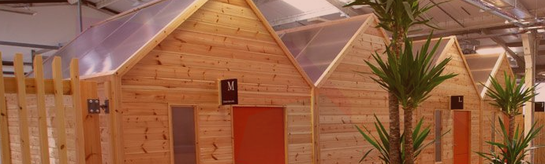

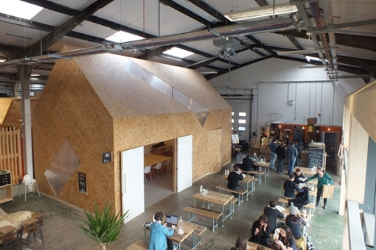

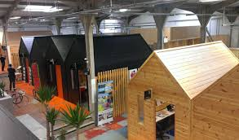

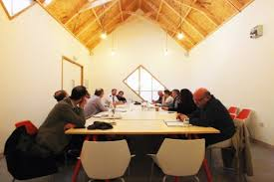

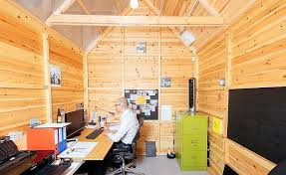

- No tiered performance space or art galleries (allows sufficient room for all other suggestions in this plan to be accommodated with reconfiguration of existing stalls)

- No second floor modifications and limited external modifications.

- Management Team led by Council Officer Amanda Davies. The BG, MT and TCF have huge respect for Amanda’s abilities and during her time in the markets she delivered significant benefits. With Amanda at the helm, leading Plan B, it is envisaged that the People’s Market would quickly improve and additional income would be generated. (Please note that no council officers or members have been contacted or have had input into Plan B).

- The full support to the WCBC management team from the BG, MT, and TCF. During 2015 TCF has successfully led and implemented a number of successful initiatives including the Wrexham Matters Newsletter, Town Centre Clean up Days, Painting of vacant properties, Support to new start -up businesses and the very successful street festival days.

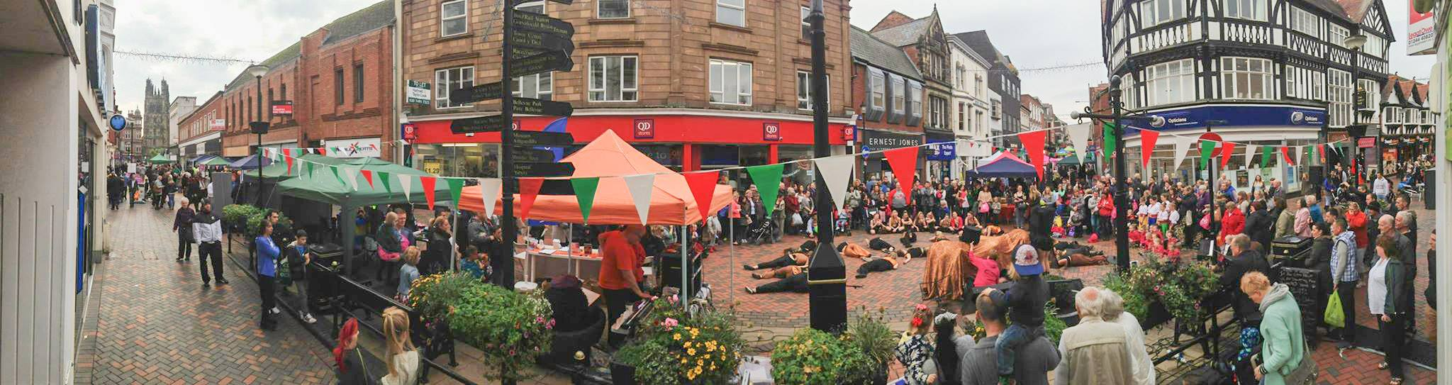

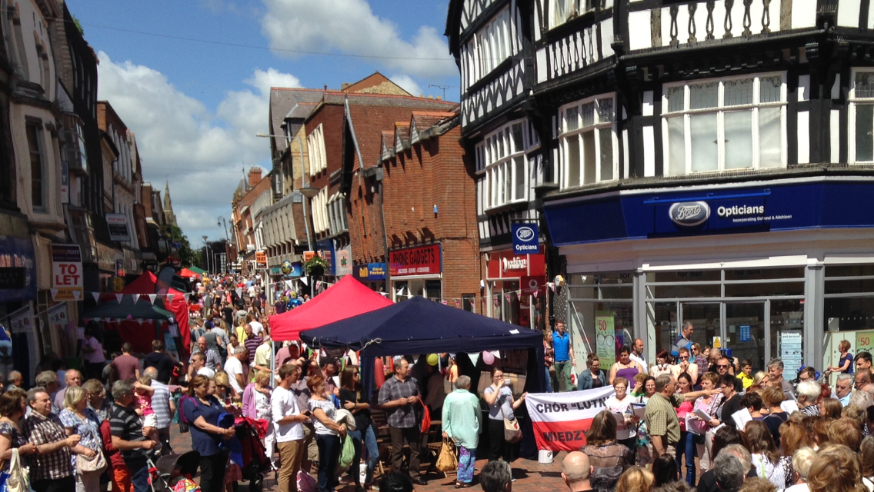

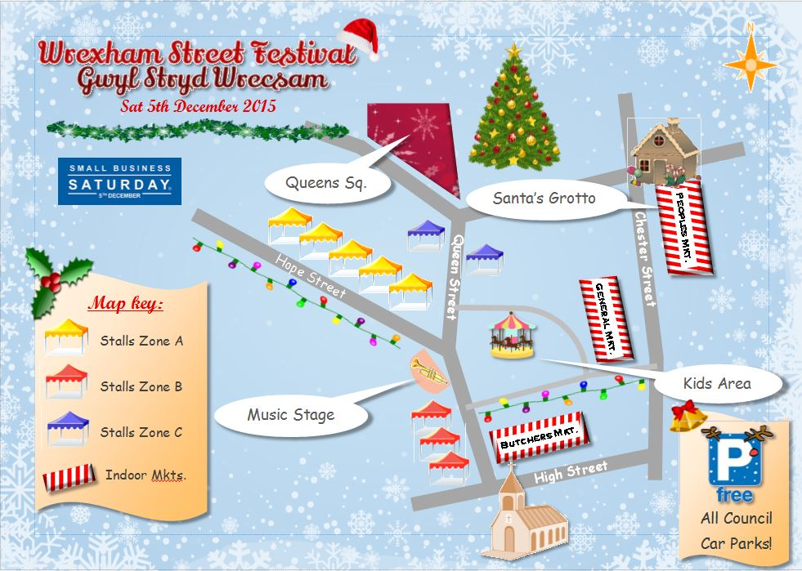

On Small Business Saturday, 5th December 2015, the Street Festival moved into the People’s Market because of adverse weather conditions. Market traders said they had not seen the People’s Market so busy and vibrant for years. The WCBC Santa helped this. This could easily be replicated with the proposed management team.

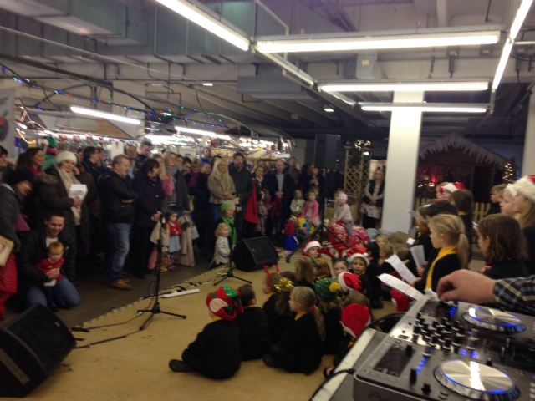

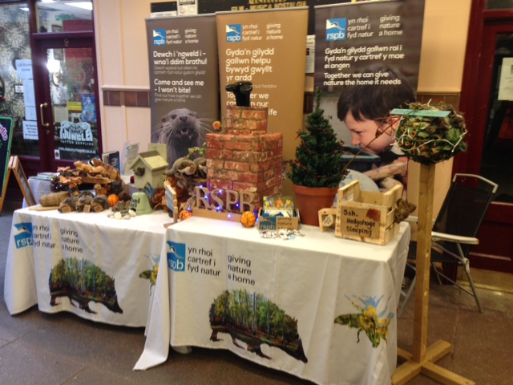

If considered desirable by WCBC – The BG and MT, with the full support of AVOW, are willing to consider setting up some form of Trust to run the facility proposed in plan B. This can be explored as and when required. The BG – Community Interest Group - is now fully set up and this would be one potential option. This Trust option would be business rather than arts led to ensure the long term viability of the Peoples Market Community Hub.

The BG is also able to offer the service of fully managing the implementation of Plan B if required and a separate proposal could be submitted. This would be a cost / no profit proposal.

It is proposed that Plan B improvements are implemented over a 12-month period subject to the availability of finance. An outline programme of works is contained in Appendix B

Plan B can be implemented in whole, or part, with any elements taken up as required – in effect Plan B is a “ shopping list”.

Please note that the figures are budgets put together in a very short time to be able to produce this report but are considered reasonably accurate for comparison against the Lead Member’s recommendations. Officers who have actual costs and income figures can more accurately define some of these figures.

Arts and Culture offering in bold italics.

Proposal | Estimated Capital Expense | Estimate Improved Revenue position  Per Annum
Project Team.  Design consultant and CDM Co-ordinator  Develop new layout  Planning applications  Layout to fully integrate Market, Arts and Culture, Sheds, Food offering, flexible spaces, fixed stalls. | £30,000
Implementation of Task and Finish Group to deal with outstanding recommendations in relation to The People’s Market. | Staff – Business as usual costs  Footfall counters – Not necessary - use manual weekly clicker
A plan to actively encourage new traders including the introduction of a food offering and installation of the previously placed on hold chillers.  Encourage many of the local food producers to trade from the market.  International foods.  Encourage arts and craft makers and local artists. | Staff – part of business as usual responsibilities. | WCBC hold this information – Need to recharge chillers costs to relevant stall holders.  Target minimum annual additional rental income – Say £2000 a month £24,000 pa
A strategy of encouraging and nurturing start-up businesses by making the People’s Market the place to expand home- based businesses and create new town centre jobs. | Currently business as usual. | Included above as part of process to increase occupancy.
Management Team – to be led by Council officer, Amanda Davies. |  | Business as usual cost
The full support to the WCBC management team from the BG, MT, and TCF or other specialist business expertise (contribution, not full cost) | Nominal contribution to the 50 weeks x £300 = £15,000
Improved marketing plan and weekly events programme. |  | Part of business as usual staff costs.  External costs say £1000 per month = £12,000 pa
Service charges: review of value for money for all service charges, not least the constant lighting to the People’s Market car park 24/7 |  | Target efficiency saving min 10% Say £10,000 pa
Building Cleanliness.  Review / improve cleaning regime |  | Business as usual cost – improved quality and specification required.
Increased occupancy of fixed stalls |  | WCBC will have figures for % increased revenue for increased occupancy
Rent review to attract new traders with incentives for existing traders. Acceptance of current rental/commercial lease terms, which include incentives such as rent and rate free periods, staggered rentals; flexible lease terms - 12 months with three month break clauses. Consider use of external agents. |  | Part of business as usual costs.
Plan B is based on flexible use of space and use of the design concept of sheds as per Liverpool’s Baltic Exchange, a successful business model. This creates a village within an existing building.  Can be used as: -  Creative spaces  Artist / Craft pods  Learning studios  Offices  Desk sharing  Business Lounge  Meeting rooms  Wi-Fi  For parties,  Network events  Much more | Purchase and set up sheds including furniture £50,000  Incudes large meeting room shed. | Target additional monthly minimum income  £ 2000 month = £24,000 pa
Flexible space - complements the flexible shed space.  This area can be used for all sorts of events, parties, performances, and concerts, craft fairs, weekly events etc.  Will encourage early evening opening.  Stage – Upgrade existing stage area.  Sound system/ Lighting  200 stacked chairs  Quality Pop Up Gazebos and tables (10 no)  (Can be used externally as well) | £20,000  £20,000  £20,000  £10,000  £5,000 | Target additional monthly minimum income  £ 2000 month = £24,000 pa
Use of Malls to encourage day traders.  This was very effective on Small Business Sat 5th December 2015  Priority for craft stalls and artisan foods to complement the next fixed food offering |  | Do every other week – 12 stalls x £10 = £3120 p.a
Market stall improvements.  Ideally new stalls – cost prohibitive. Suggest making canopies from cloth and carrying out superficial repairs. | Say £40,000 – This could be a student apprenticeship project to reduce costs – Partnership with Coleg Cambria and or Warehouse Project.
Food hall / court – Suggest open food area kitchen.  Could be used for guest cooks and cookery demonstrations.  International foods  Tables and chairs | Allow for creation of open kitchen and tables and chairs £50,000 | Will contribute to increased income.
Arts and Crafts concession area.  Create a shared space to showcase all local arts and crafts where not viable for traders to man stalls constantly. To be run by existing stallholders. | £10,000 | % commission on sales say £50 a week = £2600 p.a.
Demountable partitions to display local artists work. Run by existing stall holders | £10,000 | % commission on sales say £50 a week = £2600 p.a.
Dedicated Wrexham Heritage Stall / Area to allow all Wrexham History Groups to display on a rota basis. Steelworks, Mines, Town Centre, Brewery etc |  | Free
Building works.  Modifications / additional WC facilities  Move stair entrance directly into market hall.  Painting and decorating | £100,000
Modifications to building services. | No details of existing systems available. Say £100,000
Improve town centre accessibility for green methods – 30 Cycle Stands. | £10,000
External Improvements  Consider works of art from local artist Simon O’Rourke fixed to each elevation. | £15,000
Consider option for weekly Saturday food market on Chester Street to help link up the town. (Will require planning permission). Use gazebos and tables as included above.  Private sector may run this. Could be extended up Lambit Street to re-connect the Town Centre. | Covered above | Say 10 stalls x 52 weeks x £20 per stall. = £10,400 p.a.
Licence for corridor through old TJ Hughes, and or improved access through general market, improved signage | £50,000 | (£20,000) pa rent and insurance.  (To be confirmed with landlord)
Maximum capital cost (ex VAT) | £555,000  Plus balance of VVP of £145,000 for other deemed appropriate spend
Forecast additional annual income after costs). Ex VAT |  | £68,720.00  Say Target £70,000

  - Way Forward / Next Steps.

This proposal, subject to funding approvals, could be implemented very quickly. The works would not be required to take place all at once and could be phased over, for example, a 12 month period.

Key Actions.
See Appendix B for Draft Implementation Plan.

January 2016 – Approval to proceed with Plan B.

Late January 2016 – Form new market management delivery team including members of BG, MT and TCF

February 2016 – Engage consultant to plan new layout, and carry out detailed design. Re-submit planning application where necessary and apply for building regulation approval.

Agree overall project budgets and allocation of spend.

Appoint Project Manager – WCBC internal.

Engage services of CDM – Co-ordinator.

Prepare detailed project delivery plan and responsibility matrix.

March 2016 – Start to procure and deliver agreed priorities.

January 2017 – Plan B fully implemented.

Proposed Funding.

Capital funding from VVP or WCBC Capital budget. Consideration should also be given to re-investing market rent back into future capital improvements.

Plan B demonstrates improved operational profit.

- IMPLICATIONS

  - Policy Framework
The redevelopment of the People’s Market building to create a regenerated People’s Market with a local Arts and Culture offering contributes towards the Council’s vision for “cultural and creative activity in the visual and applied arts in Wrexham County Borough”, supports the development of new and existing businesses, and the creation of employment opportunities which are key objectives of the Council’s Economic Prosperity Strategy. In addition it will develop Wrexham as a place people want to visit and invest, and become a town where businesses can prosper. In Wrexham’s Destination Management Plan, the town centre is recognised as one of the County Borough’s four ‘tourism hubs’, as well as the Council’s wider plan to develop Welsh Language and Culture.
  - Budget
All financial details are contained in the body of this report.
This alternative proposal offers significantly fewer capital costs and focuses on additional revenue generation to create a surplus annual revenue position ensuring long-term sustainability of the People’s Market.
5.3 Legal
There are no direct legal implications as a result of this report. There is the potential to consider the taking over of the facility by a business community / trader trust or community interest company at a future date.
  - Staffing
There are no staffing implications associated with the recommendations of this report.
This alternative proposal has the added benefit of having the full support of the Market Traders, Wrexham Business Group and Chair of the Town Centre Forum who will work in partnership to develop this proposal.
The BG, MT are willing to enter into discussions to form Trust or Social Enterprise to run “ The Peoples Market Community Hub”
  - Equality/Human Rights
The proposed alternative model will be fully compliant with all equality and human right legislation and it is proposed to work actively with AVOW – Association of Voluntary Organisations in Wrexham - to ensure that the proposed facility offers equal opportunities to all groups.
5.5 Risks
A full risk assessment has not been prepared in the short time available to produce this report.
The project will comply fully with all legal and health and safety requirements.
It is considered that this proposal does not offer any risks to the existing People’s Market or the wider town centre.
This alternative proposal removes this risk of reputational damage arising to its customers and stakeholders as a result of Scrutiny Report – HAED/07/16S.
The one negative risk from this alternative proposal is that the Oriel Gallery display space will need to find alternative accommodation in the town centre if deemed financially viable. There is a wealth of suitable commercial vacant property available that could be purchased or leased. Many ‘trendy’ galleries these days are not plastered walls etc. but rugged bare basic building form with pipework etc. exposed as part of the ‘feel’. It is unfortunate that the height of the car park floors is quite low or an entire floor could be created into flexible space as stage two. There is a need for very low maintenance space as income generation would be limited.
This proposal provides a very realistic and well thought out proposal in the event that Arts Council Funding is not forthcoming.

- CONSULTATION

It is accepted that WCBC has consulted with various stakeholders and partners throughout this project and during drop-in sessions many people gave positive feedback. This however was without having finances details available so any feedback is misleading.

During December 2015 no consultation has taken place with MT, BG or TCF, despite this being a critical stage of the project.

It can be seen on Wrexham.com Facebook and forum pages that the people of Wrexham are far from supporting this project in the form currently proposed by the Lead Member. He was, in fact, warned of this festering issue in August 2015

Urgent, proper and fully transparent consultation is immediately required with all stakeholders including the BF, MT and TCF.

- BACKGROUND INFORMATION

Appendix 1 - MMU Study – Markets Matter

Appendix 2 – Outline programme of works

